SIMATS ENGINEERING
ASSESSMENT TOOL 1

COURSE NAME: Database Management Systems
COURSE CODE: CSA0509

COURSE OUTCOME COVERED

CO5: Implement database operations using query processing, optimization, and transaction management to ensure consistency and reliability. (BL3, BL4)

Activity Tool : Constraint-Based Problem Solving (High) Assessment Tool Weightage:40%

Dr

QUESTIONS
Q.N o | Question | Bloom's Level
1 | Given a complex SQL query with nested joins and sub-queries, draw the query execution plan and apply heuristic optimization rules step-by-step. | BL4 – Analyze
2 | Apply cost-based optimization to choose between nested-loop join, sort-merge join, and hash join for the given relations with specified tuple counts and page sizes. | BL4 – Analyze
3 | Implement JDBC connectivity in Java to a MySQL database and write code to execute parameterized queries with PreparedStatement. | BL3 – Apply
4 | Given a schedule of four concurrent transactions, determine whether it is conflict-serializable using a precedence graph. | BL4 – Analyze
5 | Demonstrate the application of Basic Two-Phase Locking (2PL) on a given transaction set. Identify and resolve any deadlocks. | BL3 – Apply
6 | Apply the Wait-Die and Wound-Wait timestamp-based deadlock prevention schemes on a given set of transactions requesting locks. | BL4 – Analyze
7 | Given transaction logs with checkpoints, apply the Immediate  Update recovery protocol to recover the database after a system failure. | BL3 – Apply
8 | Apply Deferred Update (NO-UNDO/REDO) recovery technique on a given log file with committed and uncommitted transactions. | BL3 – Apply
9 | Design a concurrency control mechanism using strict 2PL for a banking system where T1 transfers funds and T2 reads balance simultaneously. | BL4 – Analyze
10 | Write pseudocode for query optimization using heuristics: push down selection, project early, and order joins by smaller intermediate results. | BL4 – Analyze

Code of Conduct:

Criteria | Weightage | Level 4 (Exemplary) | Level 3 (Proficient) | Level 2  (Developi ng) | Level 1 (Beginning)
Problem Understanding | 25% | Clearly defines the problem and identifies all relevant  constraints accurately | Identifies most constraints with minor gaps | Partial  understan ding;  misses key  constraint s | Fails to identify  constraints correctly
Constraint Analysis | 25% | Analyzes constraints  effectively and  prioritizes them logically | Provides reasonable  analysis with some  prioritization | Limited analysis; weak  prioritizati on | No meaningful analysis or prioritization
Solution  Development | 25% | Develops optimal and feasible solutions | Develops workable  solutions with minor limitations | Solutions partially satisfy  constraint s | Solutions do not meet constraints
I _AKCHAYADEVI.G(192524501) (Name / Reg No) certify that this submission is my original work and that I have adhered to the guidelines specified for this assessment. I understand that any violation of academic integrity rules will result in disciplinary action.

Signature of the student: AKCHAYADEVI.G

RUBRICS FOR CALCULATION:

satisfying all
constraints
Application of Concepts | 15% | Effectively applies  appropriate concepts,  methods, or tools | Applies concepts with minor errors | Limited application ; requires guidance | Unable to apply  relevant concepts
Justification | 10% | Provides strong justification for  decisions with logical reasoning | Provides  justification with some clarity | Weak or unclear  justificatio n | No  justification provided

1. Given a complex SQL query with nested joins and sub-queries, draw the query execution plan and apply heuristic optimization rules step-by-step.

AIM
To execute a complex SQL query using nested sub-query and joins and apply heuristic optimization techniques to improve query execution efficiency.

PROCEDURE

- Create the Department and Employee tables in MySQL.
- Insert sample employee and department records.
- Use a JOIN to combine the Employee and Department tables.
- Use a nested sub-query to calculate the average salary of each employee's department.
- Select employees whose salary is greater than their department's average salary.
- Apply the condition Location = 'Chennai'.
- Execute the query and display the employee name and department name.
- Optimize the query using selection pushdown and sub-query transformation to reduce intermediate data.

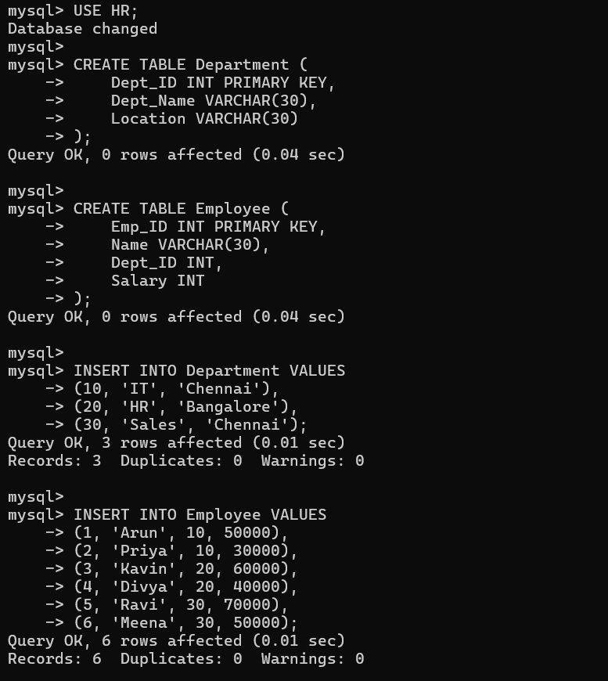

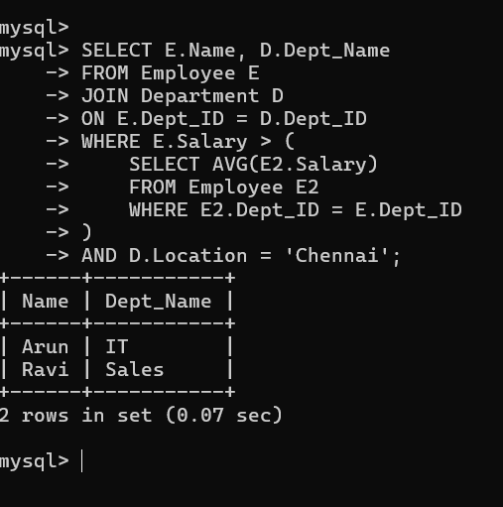
RESULT
The original query was transformed into an optimized query execution plan by pushing selections and projections downward and choosing an efficient join order. This reduces intermediate data and improves query execution speed.

2. Apply cost-based optimization to choose between nested-loop join, sort-merge join, and hash join for the given relations with specified tuple counts and page sizes.
AIM
To apply cost-based optimization to select the most efficient join algorithm among Nested-Loop Join, Sort-Merge Join, and Hash Join.
GIVEN
Assume:
- Relation R = 1,000 tuples, 100 pages
- Relation S = 500 tuples, 50 pages
- Number of buffer pages = 10
COST CALCULATION
1. Nested-Loop Join
Formula:
Cost = B(R) + B(R) × B(S)
= 100 + (100 × 50)
= 5,100 page accesses
2. Sort-Merge Join
Approximate cost:
Cost = 3(B(R) + B(S))
= 3(100 + 50)
= 450 page accesses
3. Hash Join
Approximate cost:
Cost = 3(B(R) + B(S))
= 3(100 + 50)
= 450 page accesses
COMPARISON
Join Algorithm | Estimated Cost
Nested-Loop Join | 5,100
Sort-Merge Join | 450
Hash Join | 450
DECISION
Nested-Loop Join → 5100
Sort-Merge Join → 450
Hash Join → 450
Minimum Cost = 450
Therefore, Sort-Merge Join or Hash Join is preferred over Nested-Loop Join.
If the join condition is an equality condition (=) and no sorting is already available, Hash Join is generally preferred because it can perform the join efficiently without sorting.
RESULT
Cost-based optimization compares the estimated I/O costs of different join algorithms and selects the algorithm with the lowest cost. Here, Hash Join is selected for an equality join.
3. Implement JDBC connectivity in Java to a MySQL database and write code to execute parameterized queries with PreparedStatement.
AIM
To implement JDBC connectivity between Java and MySQL and execute a parameterized SQL query using PreparedStatement.
PROCEDURE
- Create a MySQL database and table.
- Add the MySQL JDBC driver to the Java project.
- Import the java.sql package.
- Establish a connection using DriverManager.
- Create a parameterized SQL query using PreparedStatement.
- Set the required values using methods like setString() or setInt().
- Execute the query using executeQuery().
- Display the retrieved records.
- Close the ResultSet, PreparedStatement, and database connection.

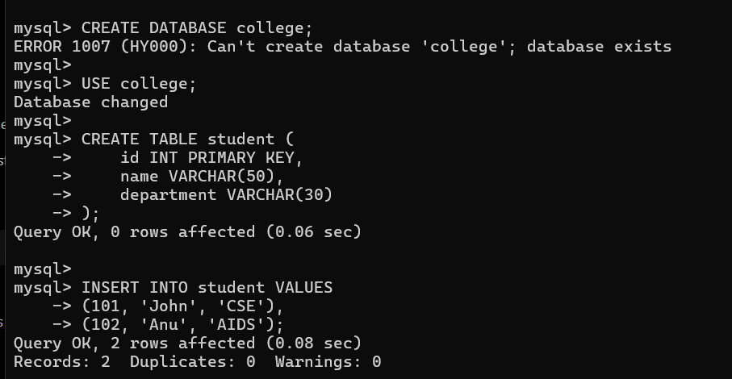

RESULT
Thus, JDBC connectivity between Java and MySQL was successfully established, and the parameterized query was executed successfully using PreparedStatement.

4. Given a schedule of four concurrent transactions, determine whether it is conflict-serializable using a precedence graph.
AIM
To determine whether a given schedule of four concurrent transactions is conflict-serializable using a precedence graph.
PROCEDURE
- Consider the given schedule containing four transactions T1, T2, T3, and T4.
- Create one node in the precedence graph for each transaction.
- Identify all conflicting operations. Two operations conflict when they belong to different transactions, access the same data item, and at least one operation is a write.
- For every conflict, draw a directed edge from the transaction performing the earlier operation to the transaction performing the later operation.
- Check the precedence graph for a cycle.
- If the graph contains no cycle, the schedule is conflict-serializable. If it contains a cycle, the schedule is not conflict-serializable.
GIVEN SCHEDULE
Consider the following schedule:
R1(A) W1(A) R2(A) W2(B) R3(B) W3(C) R4(C) W4(A)
Here, R represents Read and W represents Write.
CONFLICTS IDENTIFIED
- W1(A) → R2(A) gives T1 → T2
- W2(B) → R3(B) gives T2 → T3
- W3(C) → R4(C) gives T3 → T4
- W1(A) → W4(A) gives T1 → T4
RESULT
Thus, the given schedule is conflict-serializable, because its precedence graph contains no cycle. The equivalent serial execution order is T1 → T2 → T3 → T4.
5. Demonstrate the application of Basic Two-Phase Locking (2PL) on a given transaction set. Identify and resolve any deadlocks
AIM
To demonstrate the application of Basic Two-Phase Locking (2PL) on a given set of transactions and identify and resolve any deadlocks.
GIVEN TRANSACTIONS
Consider two concurrent transactions:
T1: Read(A), Write(A), Read(B), Write(B)
T2: Read(B), Write(B), Read(A), Write(A)
PROCEDURE
- Initially, all data items are unlocked.
- A transaction must obtain a lock before accessing a data item.
- Growing Phase: The transaction can acquire locks but cannot release them.
- Shrinking Phase: After releasing a lock, the transaction cannot acquire any new lock.
- If two transactions wait for each other, a deadlock occurs.
- Identify the deadlock using a Wait-For Graph.
- Resolve the deadlock by aborting one transaction and releasing its locks.
APPLICATION OF 2PL
Step | T1 | T2
1 | Lock-X(A) | —
2 | Write(A) | Lock-X(B)
3 | — | Write(B)
4 | Request Lock-X(B) → Wait | Request Lock-X(A) → Wait
At this point:
T1 → T2
T2 → T1
DEADLOCK DETECTION
The Wait-For Graph is:
T1
↕
T2
There is a cycle:
T1 → T2 → T1
Hence, a deadlock exists.
DEADLOCK RESOLUTION
Abort T2.
T2 → Abort
↓
Release Lock(B)
↓
T1 gets Lock(B)
↓
T1 completes
↓
Release Lock(A), Lock(B)
Then T2 can be restarted after T1 completes.
RESULT
Thus, Basic Two-Phase Locking (2PL) was successfully applied. The deadlock between T1 and T2 was identified using the Wait-For Graph, and it was resolved by aborting T2 and releasing its locks.

6.Apply the Wait-Die and Wound-Wait timestamp-based deadlock prevention schemes on a given set of transactions requesting locks.
AIM
To apply the Wait-Die and Wound-Wait timestamp-based deadlock prevention schemes on a given set of transactions requesting locks.
GIVEN
Consider three transactions with timestamps:
T1 → Timestamp = 1 (Older)
T2 → Timestamp = 2
T3 → Timestamp = 3 (Younger)
Suppose the following lock requests occur:
T1 requests a lock held by T2
T3 requests a lock held by T1
T2 requests a lock held by T3
PROCEDURE
- Assign a unique timestamp to each transaction.
- Compare the timestamp of the requesting transaction with the transaction holding the lock.
- Apply the Wait-Die rule:
  - Older transaction → Wait
  - Younger transaction → Die (Abort)
- Apply the Wound-Wait rule:
  - Older transaction → Wound (Abort) younger transaction
  - Younger transaction → Wait
- Repeat the process until all lock requests are completed.

1. WAIT-DIE SCHEME
Lock Request | Comparison | Action
T1 requests lock held by T2 | T1 is older | T1 waits
T3 requests lock held by T1 | T3 is younger | T3 aborts (dies)
T2 requests lock held by T3 | T2 is older | T2 waits
Rule
Older → Wait
Younger → Die
2. WOUND-WAIT SCHEME
Lock Request | Comparison | Action
T1 requests lock held by T2 | T1 is older | T1 wounds T2 → T2 aborts
T3 requests lock held by T1 | T3 is younger | T3 waits
T2 requests lock held by T3 | T2 is older | T2 wounds T3 → T3 aborts
Rule
Older → Wound (Abort Younger)
Younger → Wait
COMPARISON
Scheme | Older Transaction | Younger Transaction
Wait-Die | Wait | Abort
Wound-Wait | Abort younger | Wait

RESULT
Thus, Wait-Die and Wound-Wait schemes were successfully applied using transaction timestamps. Both schemes prevent deadlocks by controlling whether a transaction waits or aborts based on its age.

7. Given transaction logs with checkpoints, apply the Immediate
Update recovery protocol to recover the database after a system failure.
AIM
To apply the Immediate Update Recovery Protocol using transaction logs and checkpoints to recover the database after a system failure.
PROCEDURE
- Scan the log from the beginning and identify the checkpoint.
- Identify transactions that committed before the failure.
- Identify transactions that were active/uncommitted when the failure occurred.
- In Immediate Update, database changes may be written to disk before the transaction commits.
- Redo all committed transactions to ensure their updates are reflected.
- Undo all uncommitted transactions using their old values.
- Restore the database to a consistent state.
RECOVERY ANALYSIS
At the time of failure:
- T1 → Committed before checkpoint → REDO if required
- T2 → Committed before failure → REDO
- T3 → Not committed → UNDO
REDO T2
C: 300 → 350
UNDO T3
D: 450 → 400

RECOVERY TABLE
Transaction | Status at Failure | Action
T1 | Committed | REDO
T2 | Committed | REDO
T3 | Uncommitted | UNDO

RESULT
Thus, using the Immediate Update Recovery Protocol, the committed transactions T1 and T2 are REDONE, while the uncommitted transaction T3 is UNDONE. Therefore, the database is successfully recovered to a consistent state after the system failure.
8.Apply Deferred Update (NO-UNDO/REDO) recovery technique on a given log file with committed and uncommitted transactions.
AIM
To apply the Deferred Update (NO-UNDO/REDO) recovery technique on a given transaction log containing committed and uncommitted transactions.
GIVEN TRANSACTION LOG
Consider the following log:
<START T1>
<T1, A, 100, 150>
<T1, B, 200, 250>
<COMMIT T1>
<START T2>
<T2, C, 300, 350>

<START T3>
<T3, D, 400, 450>
<COMMIT T3>

SYSTEM FAILURE
PROCEDURE
- Read the transaction log from the beginning.
- Identify the transactions that have COMMIT records.
- Identify the transactions that were uncommitted when the system failure occurred.
- In Deferred Update, database changes are not written to the database until the transaction commits.
- Therefore, uncommitted transactions do not require any UNDO operation.
- REDO all committed transactions to apply their changes to the database.
- Ignore all uncommitted transactions.
- The database is restored to a consistent state.
RECOVERY ANALYSIS
Committed Transactions
T1 → COMMITTED
T3 → COMMITTED
Therefore, T1 and T3 are REDONE.
T1: A = 100 → 150
B = 200 → 250

T3: D = 400 → 450
Uncommitted Transaction
T2 → NOT COMMITTED
T2 is ignored because its changes were never written to the database.
RECOVERY TABLE
Transaction | Status at Failure | Action
T1 | Committed | REDO
T2 | Uncommitted | No action
T3 | Committed | REDO

RESULT
Thus, the Deferred Update (NO-UNDO/REDO) recovery technique was successfully applied. The committed transactions T1 and T3 are REDONE, while the uncommitted transaction T2 is ignored. No UNDO operation is required, and the database is restored to a consistent state.

9.Design a concurrency control mechanism using strict 2PL for a banking system where T1 transfers funds and T2 reads balance simultaneously.
AIM
To design a concurrency control mechanism using Strict Two-Phase Locking (Strict 2PL) for a banking system where T1 transfers funds and T2 reads the account balance simultaneously.
GIVEN
Assume account A has a balance of ₹10,000.
- T1: Transfers ₹2,000 from Account A to Account B.
- T2: Reads the balance of Account A.
- Strict 2PL is used to maintain consistency.
PROCEDURE
- T1 requests an exclusive lock (X-lock) on Account A.
- T1 deducts ₹2,000 from Account A.
- T1 requests an exclusive lock (X-lock) on Account B.
- T1 adds ₹2,000 to Account B.
- T1 commits the transaction.
- T1 releases all locks only after commit.
- T2 requests a shared lock (S-lock) on Account A.
- Since T1 holds the X-lock, T2 must wait.
- After T1 commits and releases the lock, T2 obtains the S-lock.
- T2 reads the updated balance and releases the lock.
EXECUTION
Initial Balance of A = ₹10,000
T1: X-Lock(A)
T1: A = A - ₹2,000
T1: X-Lock(B)
T1: B = B + ₹2,000
T1: COMMIT
T1: Unlock(A), Unlock(B)
T2: S-Lock(A)
T2: Read(A)
T2: COMMIT
T2: Unlock(A)
Execution Table
Step | T1 – Transfer | T2 – Read Balance
1 | X-Lock(A) | Wait
2 | Deduct ₹2,000 from A | Wait
3 | X-Lock(B) | Wait
4 | Add ₹2,000 to B | Wait
5 | COMMIT | Wait
6 | Release locks | —
7 | — | S-Lock(A)
8 | — | Read updated balance
9 | — | COMMIT

RESULT
Thus, Strict 2PL prevents T2 from reading the intermediate balance while T1 is transferring funds. T2 reads the balance only after T1 commits, thereby preventing dirty reads and maintaining database consistency.

10.Write pseudocode for query optimization using heuristics: push down selection, project early, and order joins by smaller intermediate results.
AIM
To write pseudocode for query optimization using heuristic rules such as selection pushdown, early projection, and ordering joins to produce smaller intermediate results.
PSEUDOCODE
BEGIN
INPUT: SQL Query
1. Parse the SQL query.
2. Convert the query into a relational algebra expression.
3. Apply Selection Pushdown:
FOR each selection condition
Move the selection as close as possible to the base table.
END FOR
4. Apply Early Projection:
FOR each relation
Keep only the attributes required for
selection, join, and final output.
END FOR
5. Order Joins:
Identify all join operations.
Estimate the size of each intermediate result.
Perform the join that produces the smallest
intermediate result first.
Continue until all relations are joined.
6. Generate the optimized query execution plan.
7. Execute the optimized plan.
8. Display the result.
END
HEURISTIC RULES
- Push Down Selection → Apply filtering as early as possible.
- Project Early → Remove unnecessary columns early.
- Order Joins → Perform joins that produce smaller intermediate results first.
RESULT
Thus, the query optimization pseudocode was successfully designed using selection pushdown, early projection, and efficient join ordering, thereby reducing intermediate results and improving query execution efficiency.

